LINXtec
FERROMECANICA HEAVY INDUSTRIES

BUDD-FERROMECANICA RDC-91 DIESEL MULTIPLE UNIT:

SUMMARY:
Using status quo engines, transmissions and electro-mechanical components of the Rail Diesel Car, we seek to build a 3 car DMU that is permanently married and offers the following features
-Multi Function car for Conductor and for Wheelchair access
-Automatic doors throughout the train, controlled from MFC
-Dedicated cabs at each end for the crew that are permanently mounted, not collapsing
-Modern interiors.

The fleet will be built from a series of prototypes, including 2 from Allearth Rail of Vermont, with one RDC-2 converted to RDC-3 and placed in the middle of the set, and another RDC-3 placed into the middle of the set. The others will come from the British Columbia Railway and the Alaska Railroad, by way of the third-hand market and Trimet of Oregon.

The aim is to immediately launch these trains on Barrie’s suburban rail network, including Lines S12, S18 and S6.

Eventually Ferromecanica wishes to acquire the production rights to the Rail Diesel Car range, and open a factory to start serial production again. Every variant from RDC-1 to RDC-9 will be produced alongside RDC-91.

Our RDC-1s will also be retrofitted with A-end automatic doors and steps where safely possible to do so. If necessary, we will relocate mechanical components to allow for this. This gives us 4 full sets of doors per sets per side, 8 total. The components will remain on the underside of the trains.

LAUNCH ROUTES
Barrie City Railways/LINX Rail Services Line S12
LINX Rail Services Line S18, Barrie to Midhurst.

These trains will be the launch product of a future LINXNet division, LINXTec and its subsidiary Ferromecanica Heavy Industries, which we wish to position as a railway manufacturing and rebuilding enterprise. FHI will exist to provide some exportable domestic designs that LINX Rail will ultimately be the launch customers of. The RDC-91 will be the first product we ever make at Ferromecanica, by modifying the Budd RDC fleets below to our Standard. Once these are complete, we will cascade them onto our mainlines, as 6-car, 2-MU trains, on Line S1 and S18, and as a 3 car. 1-MU set on Line S11.
BUDD RDC-91
LINE S1 SPECIFICATION
Combine an RDC-3 or RDC-2 with two RDC-1 Cab Ends
Add Automatic Doors on the Central entrances, with the Front Cabs completely set up for Cab Use Only, with the cabs still being able to allow access between trains.
Design to be integrated with the DR-1 Diesel Multiple Unit.
Vmax upgraded to 75mph
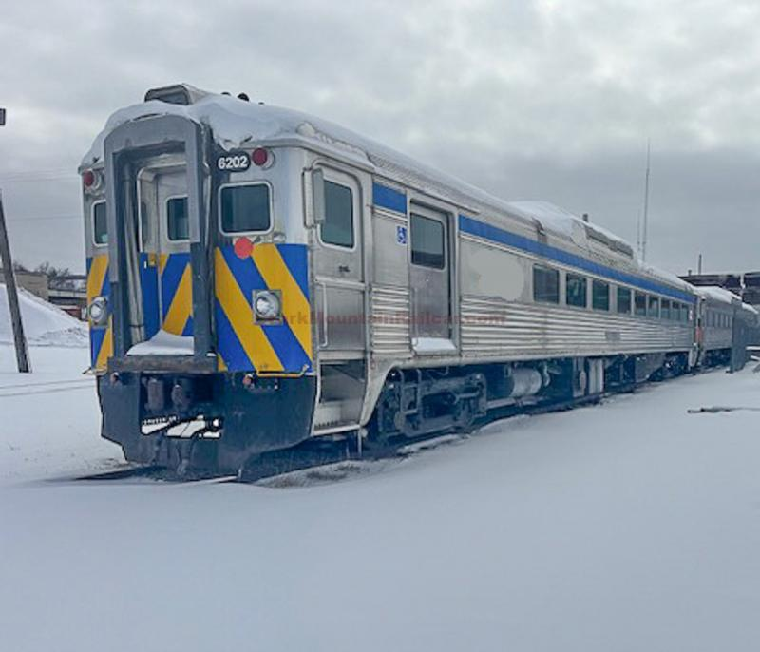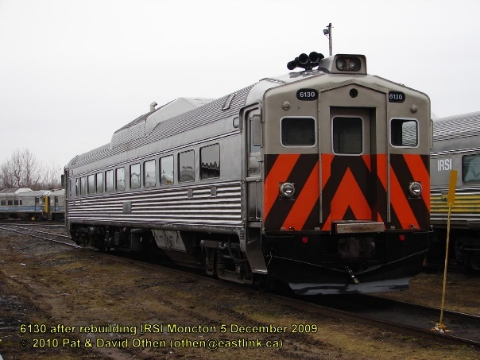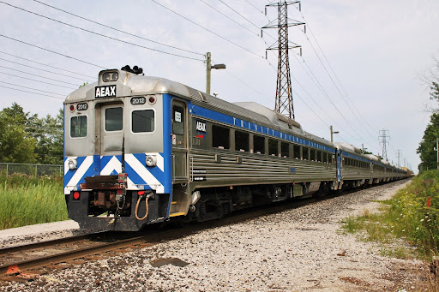
AEAX 6202, 6130 (RDC-2)
AEAX 2005, 2013, 2003, 2009 (RDC-1)
Ferromecanica RDC-91 Prototypes
PWR: 6x Cummins NTA855R, Allison Automatic
SPEC : Permanently married, 3 car sets,with two RDC-1 control cars, from refurbished green and white AllEarth units, retrofitted with permanent cabs at the A end, and retaining permanent washrooms at B-end. RDC-2s would have cabs removed, with both ends turned into Car C, with the B-ends of the RDC-1s and both vestibules of the RDC-2, retrofitted to be Automatic doors, with the Conductor in Module C controlling the doors from his office like he would on a Multi-Function car on a Bi-Level or Intercity set. Cab access for the RDC-1 would be retained by modifying the conductor side door into an access door, while the engineer’s cab would be permanently welded in place
ASSSIGN: LINX-R Line S1, D-9101 to D-9102, with A and B modules reserved for the RDC-1 driving ends, and C module reserved for RDC-2. Additional units would be converted from BC Rail survivors below

LINX RAIL SERVICES/BARRIE CITY RAILWAYS RDC-91, M-9101
Launch on Line S12 as Barrie City Railways before LINX Rail is established and uploaded.
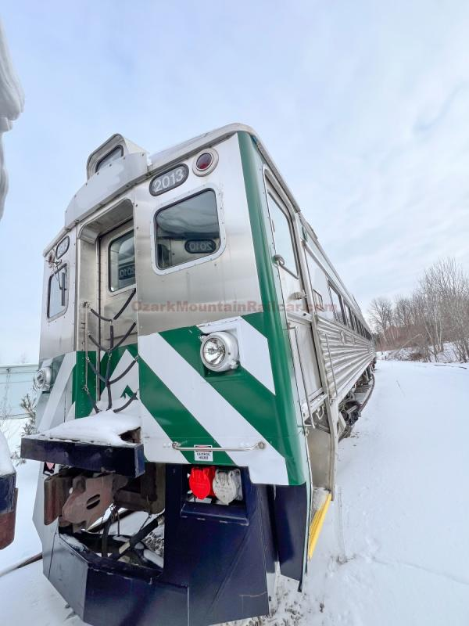
https://ozarkmountainrailcar.com/railEquipment.php?itemId=4133&category=Passenger%20Equipment
ALL EARTH RAIL 2013
PWR: 2x Cummins NTA855R, Allison Automatic
SPEC : Permanently married, Control Car A
Mate with RDC 6202
Equipped with bright AllEarth interior, which 6202 would be refurbished with.

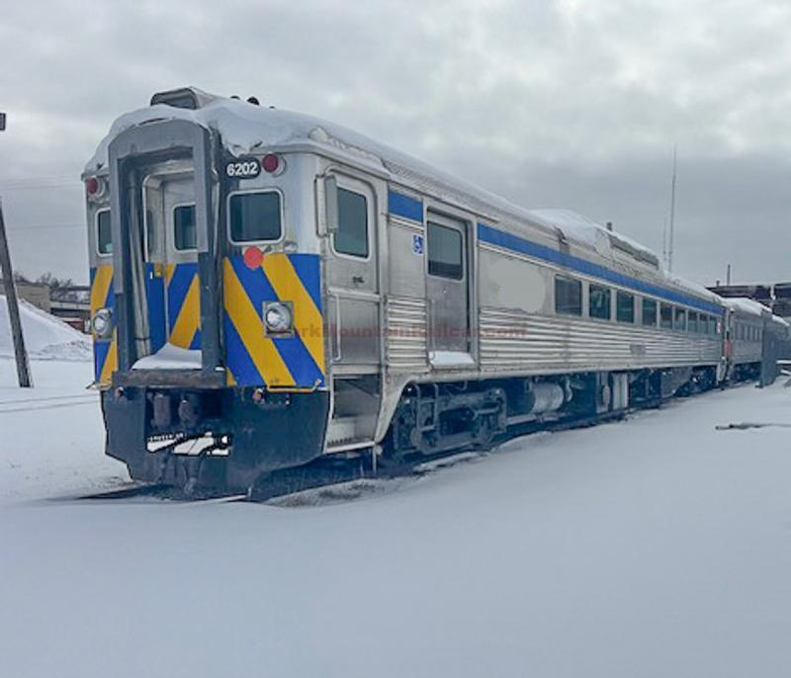
https://ozarkmountainrailcar.com/railEquipment.php?itemId=4144&category=Passenger%20Equipment
ALLEARTH 6202
RDC-2
PWR: 2x Cummins NTA855R, Allison Automatic
SPEC : Permanently married, Multi Function Car C. Remove Controls
The B ends of Control Cars A and B, directly mated to this car’s vestibules, will be drawbarred, and have the Controls removed. Automatic doors will be offeed throughout the train, and the RDC-2 being convererted to a Multi-Function car. The RDC-2 doors will be removed, and the car will be converted to an RDC-3 with larger doors set further back.

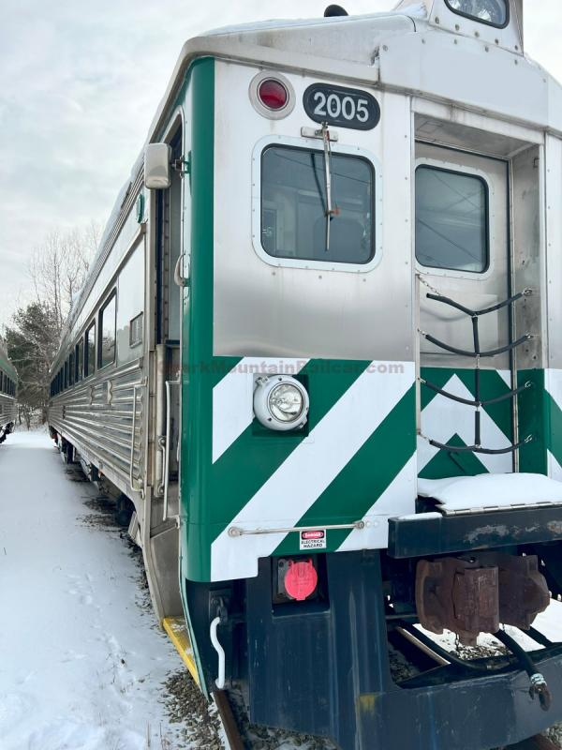
https://ozarkmountainrailcar.com/railEquipment.php?itemId=4127&category=Passenger%20Equipment
ALL EARTH RAIL 2005
PWR: 2x Cummins NTA855R, Allison Automatic
SPEC : Permanently married, Control Car B
Mate with RDC 6202
Equipped with bright AllEarth interior, which 6202 would be refurbished with.

LINX RAIL SERVICES/BARRIE CITY RAILWAYS
FERROMECANICA RDC-91 M-9102.
Launch on Barrie City Railways before LINX Rail Services upload.
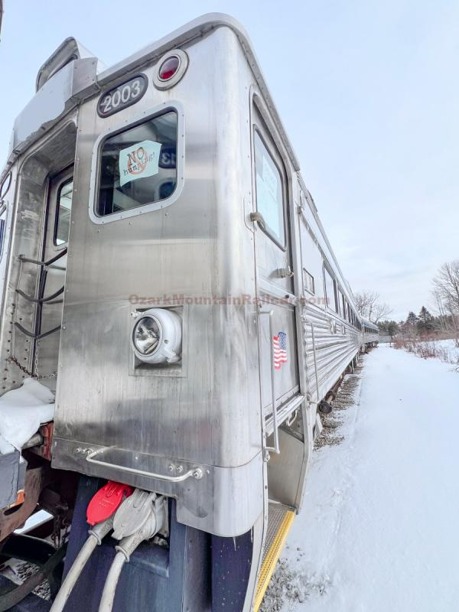
https://ozarkmountainrailcar.com/railEquipment.php?itemId=4125&category=Passenger%20Equipment
ALLEARTH RAIL 2003
PWR: 2x Cummins NTA855R, Allison Automatic
SPEC : Permanently married, Control Car A
Mate with RDC 6202
Equipped with bright AllEarth interior, which 6202 would be refurbished with.

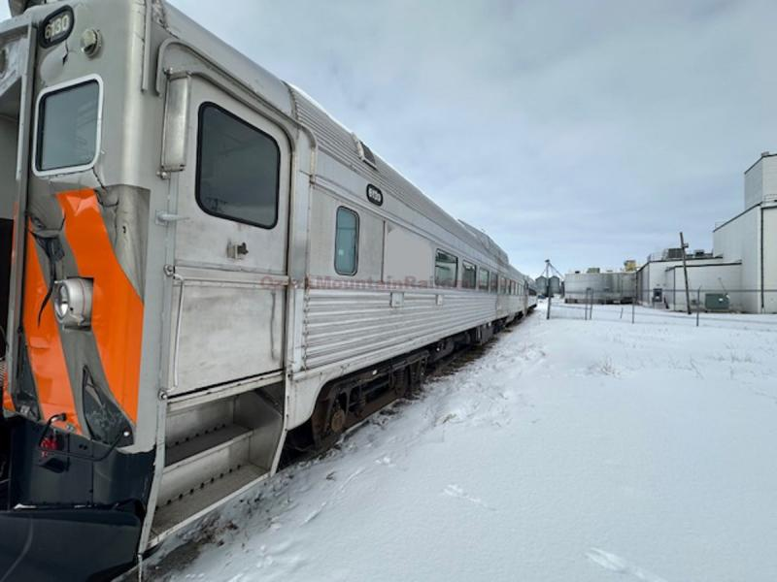
ALLEARTH 6130
RDC-1M
PWR: 2x Cummins NTA855R, Allison Automatic
SPEC : Permanently married, Multi Function Car C. Remove Controls
The B ends of Control Cars A and B, directly mated to this car’s vestibules, will be drawbarred, and have the Controls removed. Automatic doors will be offeed throughout the train, and the RDC-2 being convererted to a Multi-Function car. The RDC-2 doors will be removed, and the car will be converted to an RDC-3 with larger doors set further back.
NOTES: Built as an RDC-1 and prototyped to RDC-2 or RDC-3 spec with onboard galley, which we’d retain for the RDC-3 prototype.
The galley is located directly behind the vestibule. We would locate the Multi-Function doors at the other end of the coach, the goal being to mate this car to 2003 and 2009.

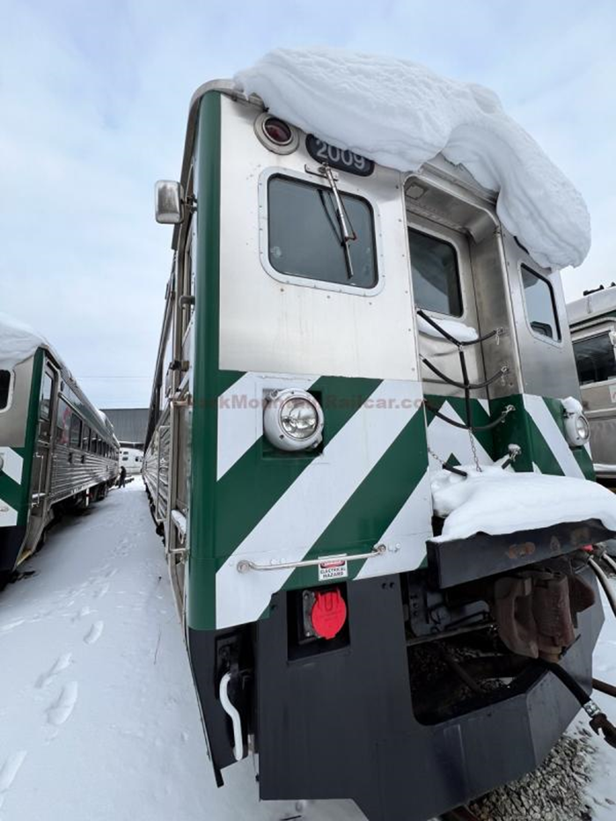
ALL EARTH RAIL 2009
PWR: 2x Cummins NTA855R, Allison Automatic
SPEC : Permanently married, Control Car B
Mate with RDC 6202
Equipped with bright AllEarth interior, which 6202 would be refurbished with.
ACQUIRE FROM THIRD HAND SOURCE

PRODUCTION SERIES
Rebuilt from the entirety of the BC Rail Cariboo Prospector fleet
This fleet will serve LINX Rail Services when the network is uploaded to the County. Once these Prototypes are complete, Ferromecanica will file a patent with the Government of Canada and propose serial production of this train, with potential customers including VIA Rail Canada, the Island Corridor Foundation, Ontario Northland and LINX Rail themselves. LINX Rail will operate the entire Prototype Class of the RDC-91 from BC Rail, with the first prototypes being trains made with two RDC-1s and an RDC-3, and the rest being made with conversion of surplus RDC-1s to an RDC-3M spec. The first four trains will launch alongside AllEarth’s RDC-91 contingent, with the rest being used for expansion.
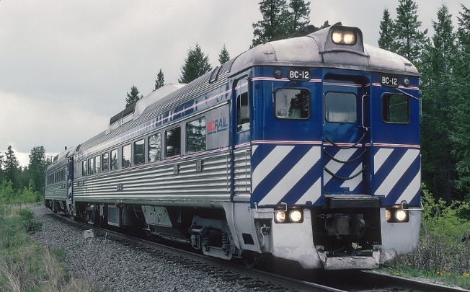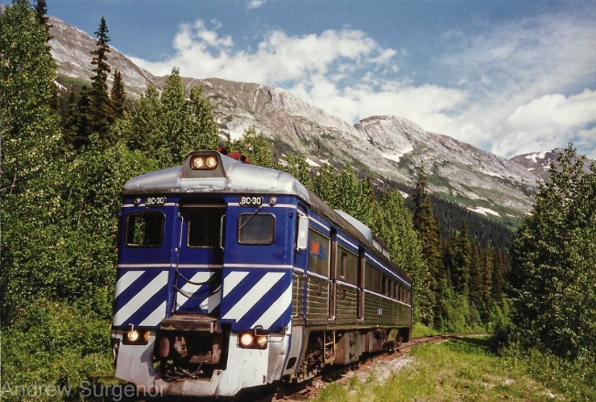
BC RAIL BC-10 to BC-15, BC-21 to BC-23 (RDC-1)
BC Rail BC-30 to BC-33 (RDC-3)
Ferromecanica RDC-91 Prototypes
PWR: 6x Cummins NTA855R, Allison Automatic
SPEC : Permanently married, 3 car sets,with two RDC-1 control cars, from refurbished BCR units retaining their exterior specs, including Airchime K5L horns, Brass Bells, and semi-streamlined appearance, retrofitted with permanent cabs at the A end, and retaining permanent washrooms at B-end. RDC-2s would have cabs removed, with both ends turned into Car C, with the B-ends of the RDC-1s and both vestibules of the RDC-3, retrofitted to be Automatic doors, with the Conductor in Module C controlling the doors from his office like he would on a Multi-Function car on a Bi-Level or Intercity set. Cab access for the RDC-1 would be retained by modifying the conductor side door into an access door, while the engineer’s cab would be permanently welded in place
ASSSIGN: LINX-R Line S1, D-9201 to D-9205, with A and B modules reserved for the RDC-1 driving ends, and C module reserved for RDC-2. The goal is to match all RDC-3s with two semi-streamlined RDC-1s, fitted out for Line S1. Rock Lights would be retained, and upgraded to two Ditch Lights in the outer corners, while Inner Corners would have halogen Red DPU lights.
To account for less RDC-3s than required, some RDC-1s will be converted to Multi-Function C-modules from scratch.

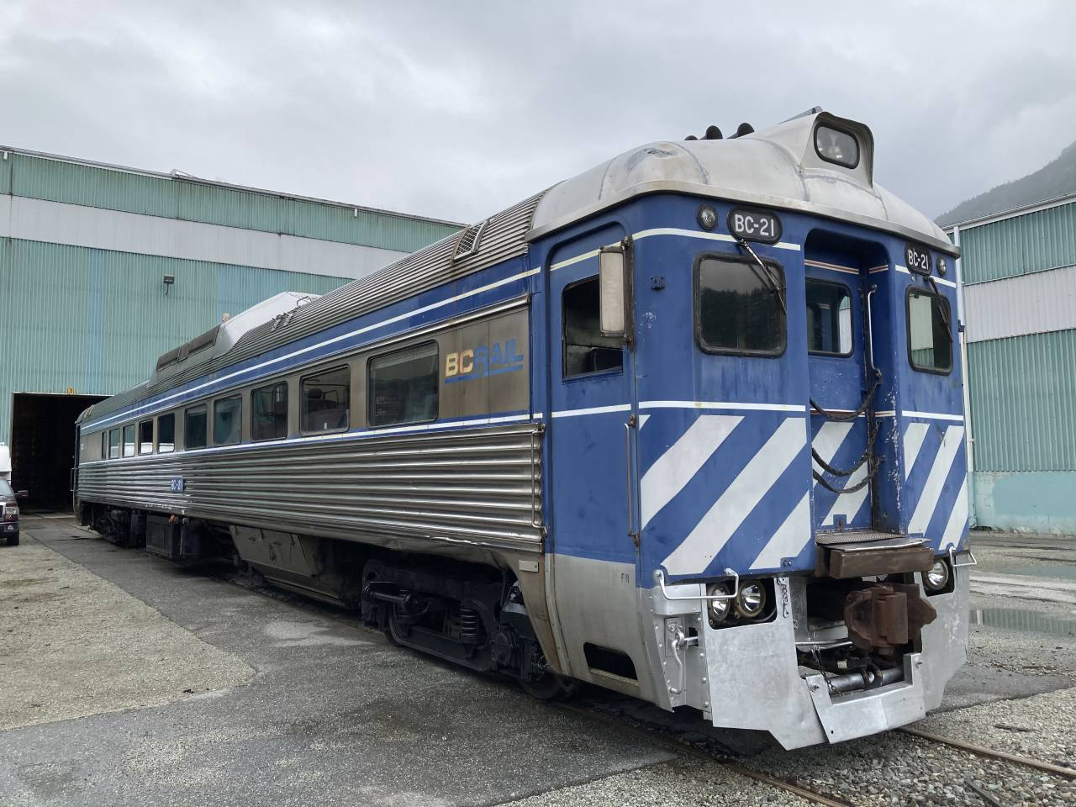
BC RAIL BC-10 to BC-15, BC-21 to BC-21
RDC-1
PWR: 2x Cummins NTA855R, Allison Automatic
SPEC : Permanently married, Control Car B
Mate with RDC 6202
Equip with upgraded interiors.
The fronts of these cars shown, with Rock Lights and Streamlined car, will be the FA and FB end of the RDC-91. Permanently set up for control, the access doors for passengers will be at the B end and Midship of these cars.
Our spec will retain the Rock Lights, with the outer lights used as Ditch Lights, and the inside lights used as Red DPU lights augmenting the DPU lights on the top of the nose.

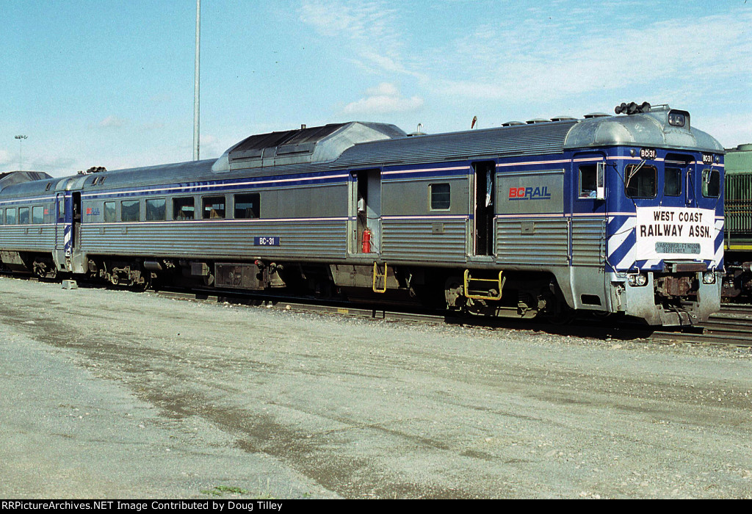
BC RAIL BC-30 to BC-33
RDC-3
PWR: 2x Cummins NTA855R, Allison Automatic
SPEC : Permanently married, Multi-Function Car C
Mate with BC-10 to BC-23
Equip with upgraded interiors.
These cars will become Multi-Function cars. The centre doors will be kept, the frontmost removed, for an automatic Accessibility Lift. The vestibules will have the controls removed to be permanently mated to the consist. Since only four cars were ordered, select RDC-1s will be turned into RDC-3Ms for with this conversion done.
The RDC-91 models will be classed RDC 9120 and RDC-9130, with 9131-9134 being the prototypes of BC-30 to BC-33, and the 9120 class being assigned to models with converted RDC-1 redundancies.
The goal is to make enough trains and equally use the stock from BCR, to build an entire fleet of RDC-91s with no leftovers.
All C cars will have Accessibility, Onboard Galley, and AODA seating aboard.

